**The effect of alternative data weightings on m3 Operating model estimates of Atlantic bluefin tuna stock size and mixing**

Tom Carruthers[1], Doug Butterworth[2]

*SUMMARY*

To do last

*KEYWORDS*

*Operating model, sensitivity analysis, data weighting, bluefin tuna, stock assessment*

# Introduction

Modern integrated stock assessments are typically fitted to numerous data sources including catch observations, relative abundance indices and catch composition data. Typically, these stock assessment models weigh various data to ensure estimation convergence and achieve residuals errors comparable to those specified in the observation error models (e.g. a 10% log normal residual error in observed catch data) in a process known as ‘iterative reweighting’ (McAllister and Ianelli REF, Methot and Wetzel REF).

The behavior of age-structured stock assessments (e.g. statistical catch at age or virtual population analyses) can be complex and unpredictable. Although parameters such as natural mortality rate and stock recruitment compensation (steepness) tend to be the most consequential, the exact magnitude and relative importance of the various parameters can vary substantially among stock assessments. Model predictions of quantities of management interest (e.g. current spawning stock depletion) and related reference points (e.g. current biomass relative to biomass at maximum sustainable yield) are often not linearly or intuitively related to assessment input parameters and data weightings. It is customary to conduct sensitivity analyses the various assessment assumptions, parameters and data on determining outputs are varied to evaluate their relative impact on assessment outputs.

We conducted such an analysis for five reference operating models of the ABT-MSE framework, evaluating the relative sensitivity of model estimates of stock biomass and mixing to down weightings for various input data.

# Methods

The sensitivity analysis of down weighting was conducted for five operating models of the reference set:

#1 (1AI: recruitment level 1, abundance level A, mortality / maturity level I),

#2 (2AI: recruitment level 2, abundance level A, mortality / maturity level I),

#7 (1AII: recruitment level 1, abundance level A, mortality / maturity level II),

#8 (1BIII: recruitment level 2, abundance level A, mortality / maturity level III),

#16 (2AII: recruitment level 2, abundance level A, mortality / maturity level II)

We investigated a downweighing to 1/5 of base case levels for:

eastern relative abundance indices (CPUE and fishery independent in the Eastern area)

western relative abundance indices (CPUE and fishery independent in the Eastern area)

stock of origin data (both otolith microchemistry and genetics)

electronic tagging data (e.g. PSATs)

otolith microchemistry data

Individually, we considered the impact of these down-weightings on estimates of East and West area biomass, East and West stock biomass and the extent of stock mixing.

# Results

## Reference Set Operating Model 1 (1AI)

**Table 1**. Weighted negative log-likelihood components (relative to the base case OM1: 1AI) among 80% down-weightings to the Eastern abundance indices (East_I, CPUE and fishery-independent), Western indices (West_I, , CPUE and fishery-independent), stock of origin data (SOO, both otolith microchemistry and genetics), Electronic tagging (Etag) and only the otolith microchemistry Stock of origin data (SOO_MC). The columns represent various data types and priors: Cat = catch data by fleet, quarter and area. CR = the fishery dependent catch rate (CPUE) indices, Surv = fishery-independent survey indices, Comp = length composition data, SOO = stock of origin data, ET = Electronic tagging data, Rec = prior on recruitment deviations, Mov = prior on movement parameters, Sel = prior on size selectivity parameters, SRA = penalty incurred when catches exceed F=1 catches in the stock reduction analysis phase (1864-1964), MI = a prior on similarity to the 'Master Index' that predicts F by year, area, season and fleet, R0dif = a prior on the difference in R0 estimated in two-phase recruitment models (recruitment level 1 and 3), TOT = total global objective function, TOTn = total global objective function without priors. Each column (data type, prior) is individually color-coded from green (lower value - good fit) to red (highly value - bad fit). Note: this is not comparable among rows for the data type that is subject to reweighting.

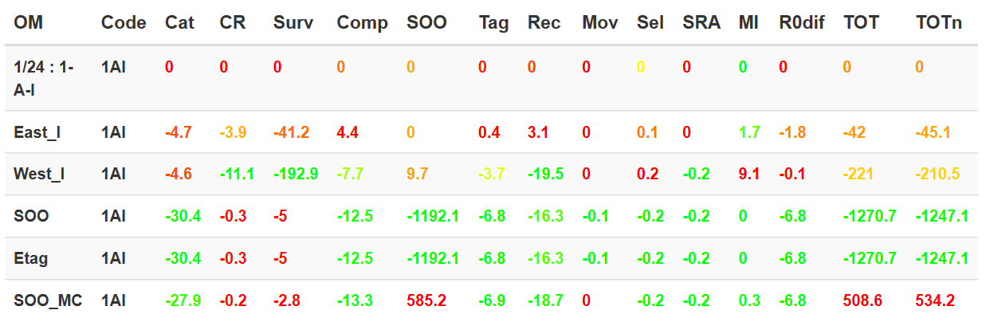

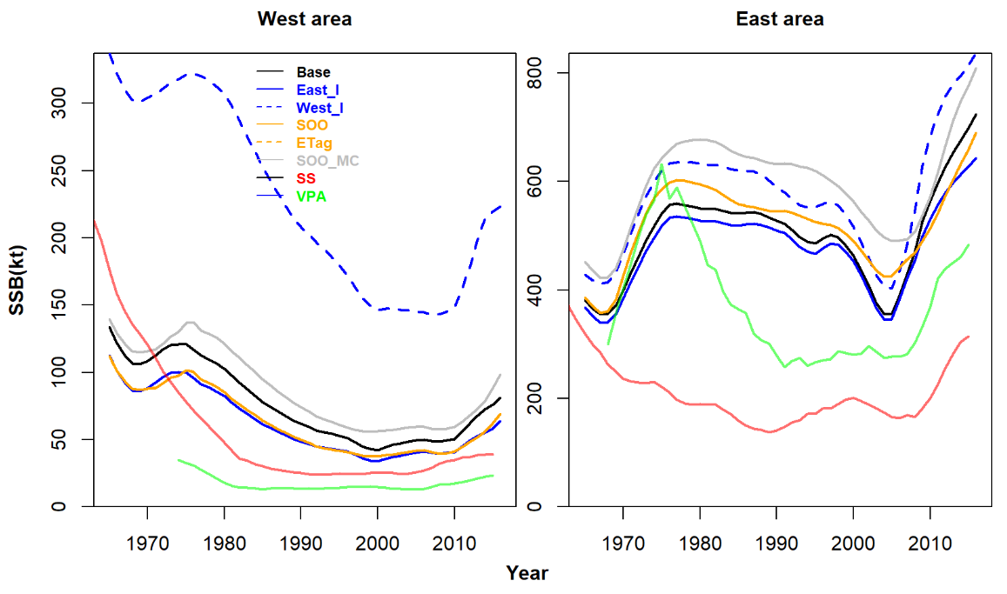

**Figure 1a**. The sensitivity of area estimates of spawning stock biomass (SSB) for operating model 1 (1AI) and 80% down-weightings to the Eastern abundance indices (East_I, CPUE and fishery-independent), Western indices (West_I, CPUE and fishery-independent), stock of origin data (SOO, both otolith microchemistry and genetics), Electronic tagging (Etag) and only the otolith microchemistry Stock of origin data (SOO_MC).

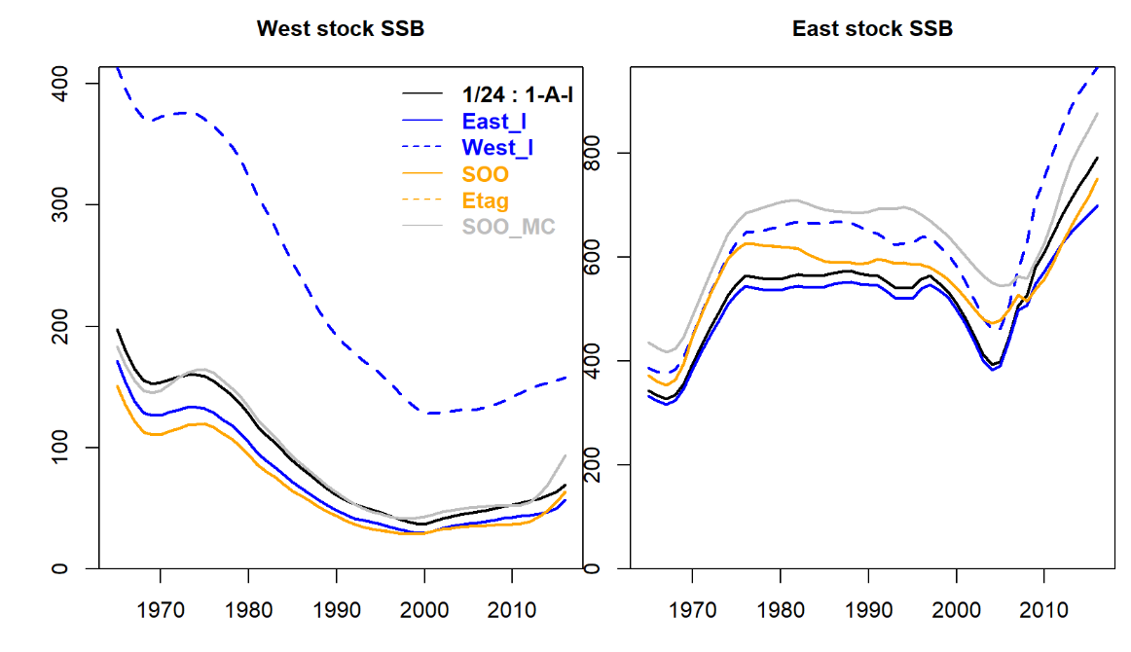

**Figure 1b**. The sensitivity of estimates of spawning stock biomass (SSB) by stock for operating model 1 (1AI) and 80% down-weightings to the Eastern abundance indices (East_I, CPUE and fishery-independent), Western indices (West_I, CPUE and fishery-independent), stock of origin data (SOO, both otolith microchemistry and genetics), Electronic tagging (Etag) and only the otolith microchemistry Stock of origin data (SOO_MC).

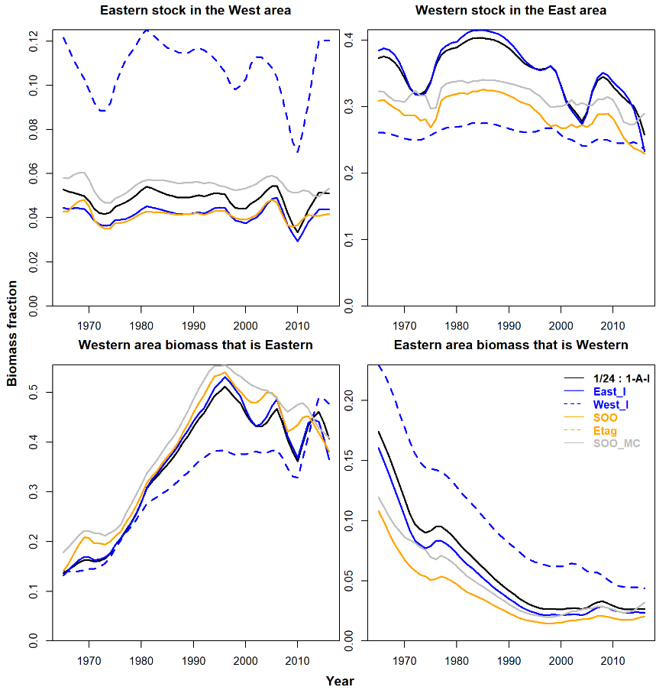

**Figure 1c**. The sensitivity of estimates of mixing for operating model 1 (1AI) and 80% down-weightings to the Eastern abundance indices (East_I, CPUE and fishery-independent), Western indices (West_I, CPUE and fishery-independent), stock of origin data (SOO, both otolith microchemistry and genetics), Electronic tagging (Etag) and only the otolith microchemistry Stock of origin data (SOO_MC).. The top row shows the fraction of each stock in the opposite area. For example, the top left shows, of the total biomass of the Eastern spawning stock, what fraction is found in the West. This varies over time due to heterogenetic in movement with age class and varying strength of the various age classes. The bottom row show the fraction of the regional biomass that is made up of the opposing stock. For example the lower right panel shows, of all fish in the Eastern area, what fraction are of the Western stock. This varies over time, principally due to the relative magnitude of the two stocks.

## Reference Set Operating Model 2 (2AI)

Table 2. As Table 1 but for OM #2 (2AI)

. 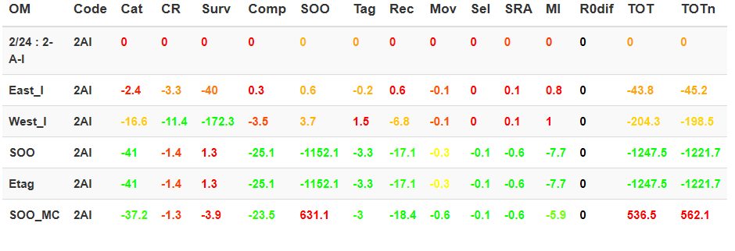

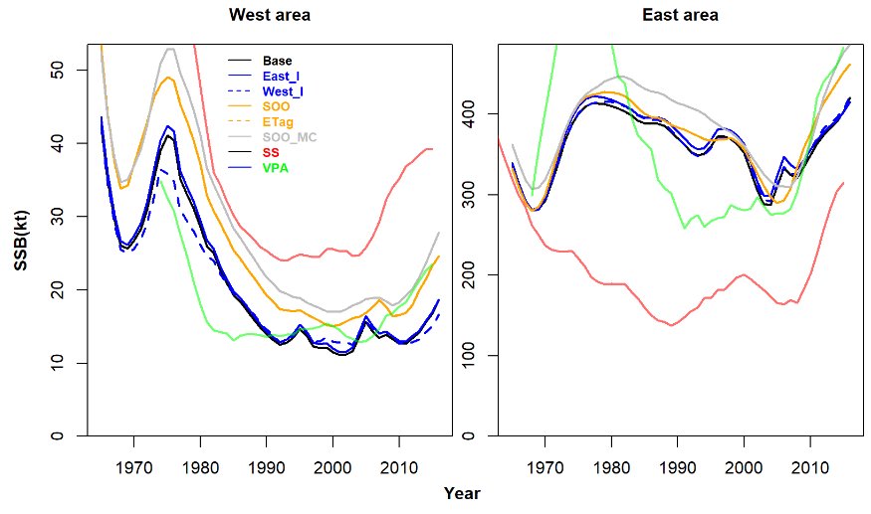

Figure 2a. As Figure 1a but for OM #2 (2AI)

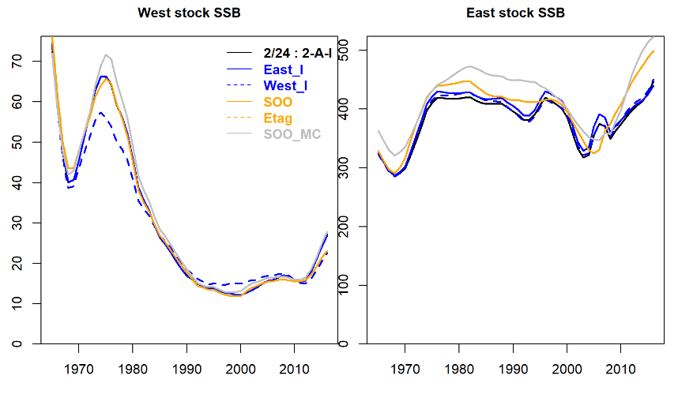

Figure 2b. As Figure 1b but for OM #2 (2AI)

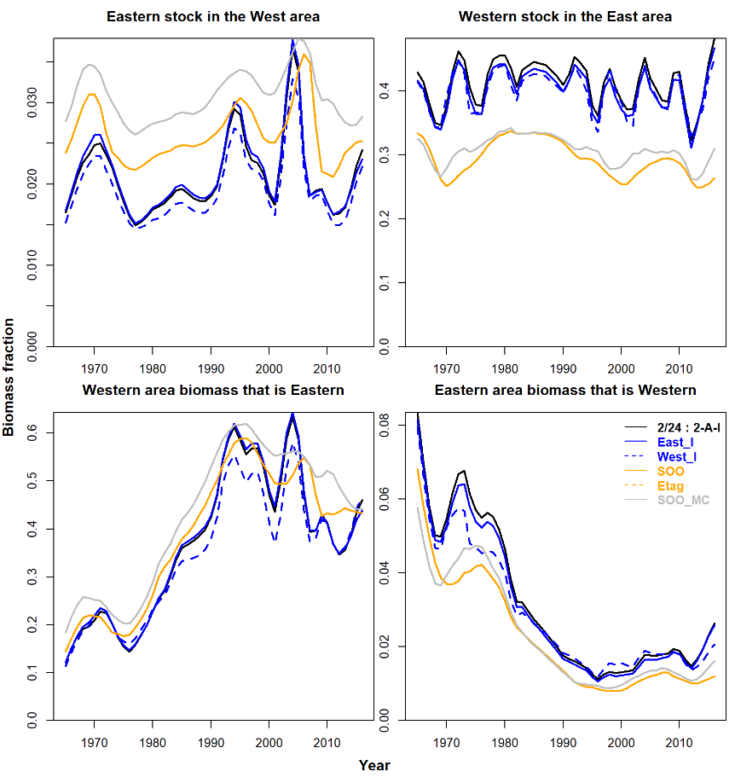

Figure 2c. As Figure 1c but for OM #2 (2AI)

## Reference Set Operating Model 7 (1AII)

Table 3. As Table 1 but for OM #7 (1AII)

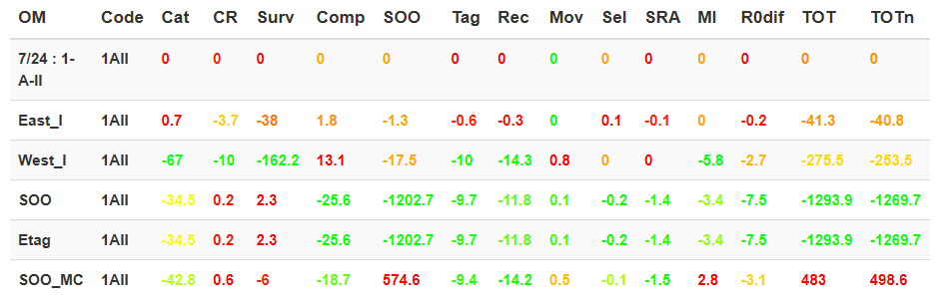

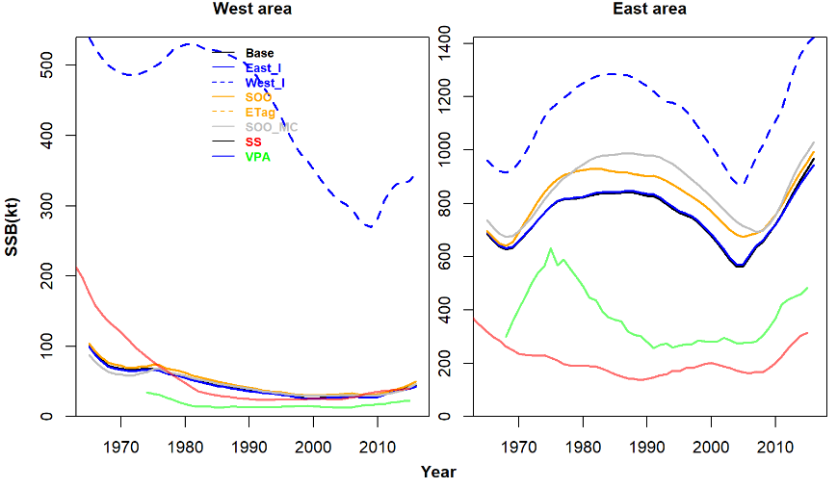

Figure 3a. As Figure 1a but for OM #7 (1AII)

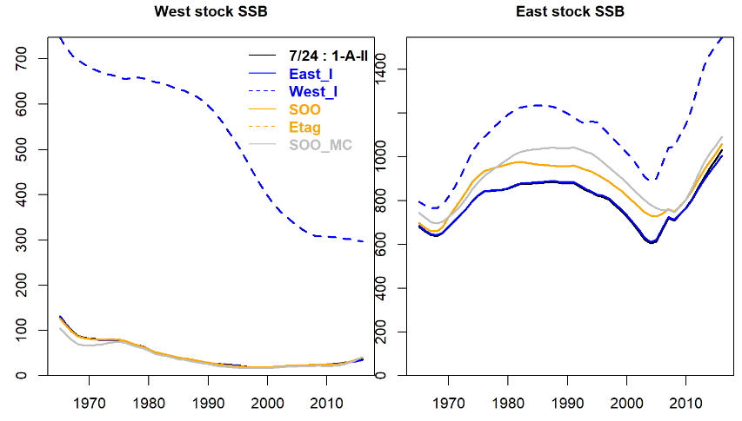

Figure 3b. As Figure 1b but for OM #7 (1AII)

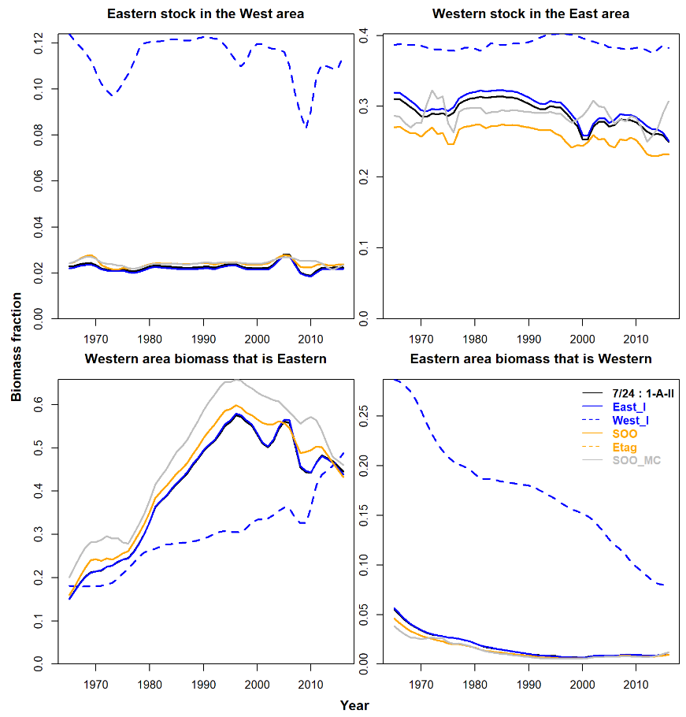

Figure 3c. As Figure 1c but for OM #7 (1AII)

## Reference Set Operating Model 8 (2AII)

Table 4. As Table 1 but for OM #8 (2AII)

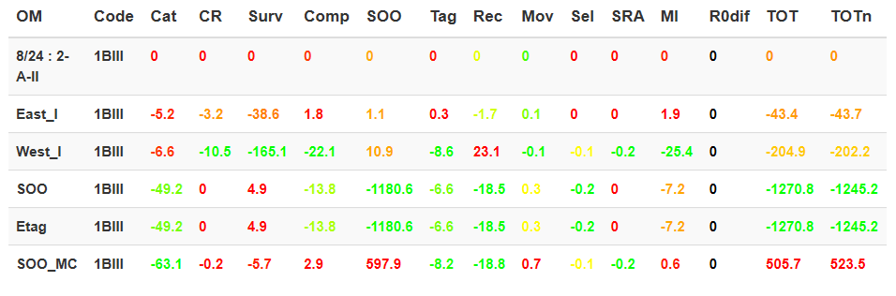

.

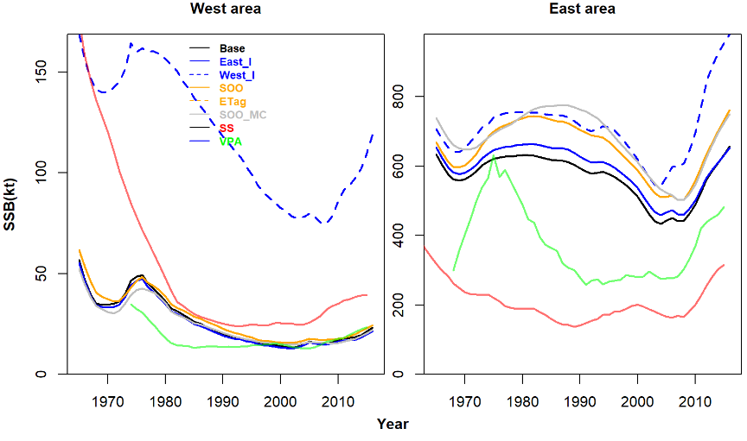

Figure 4a. As Figure 1a but for OM #8 (2AII)

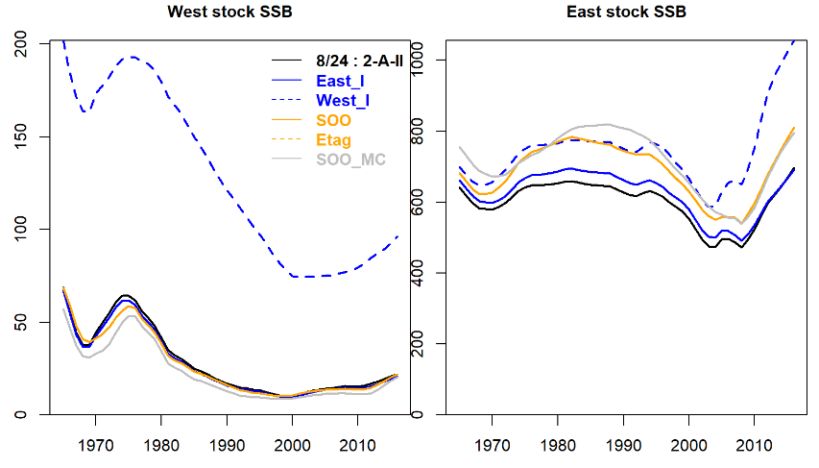

Figure 4b. As Figure 1b but for OM #8 (2AII)

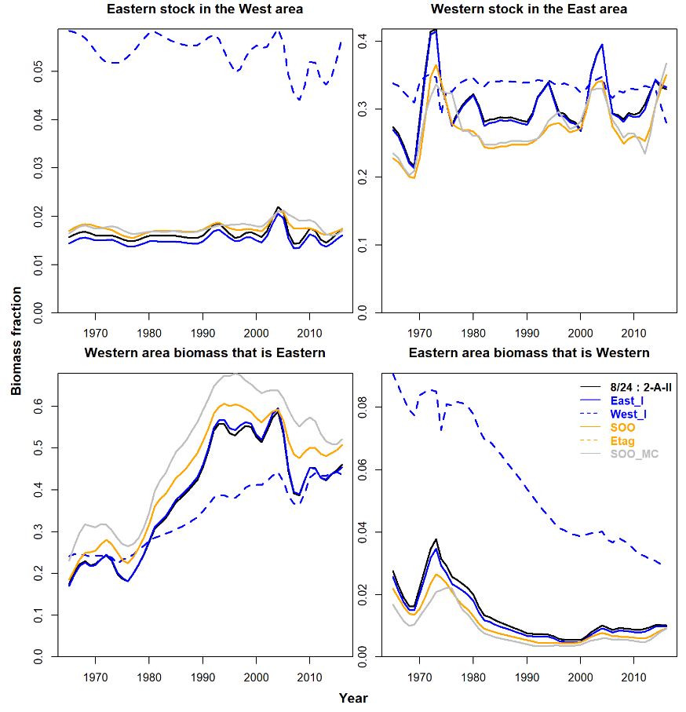

Figure 4c. As Figure 1c but for OM #8 (2AII)

## Reference Set Operating Model 16 (1BIII)

Table 5. As Table 1 but for OM #16 (1BIII)

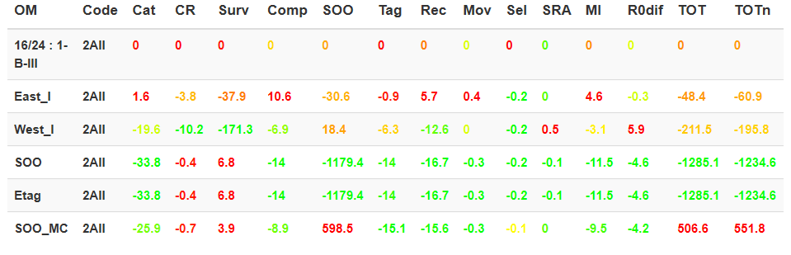

.

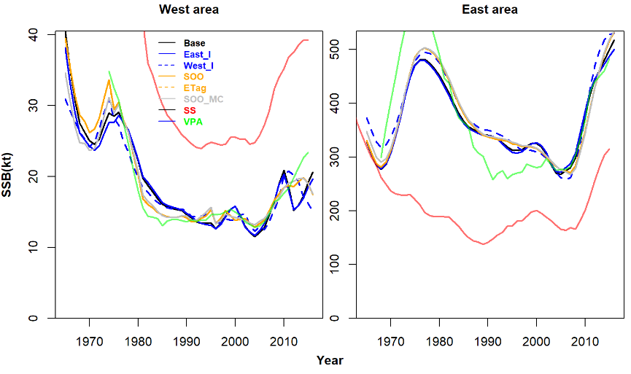

Figure 5a. As Figure 1a but for OM #16 (1BIII)

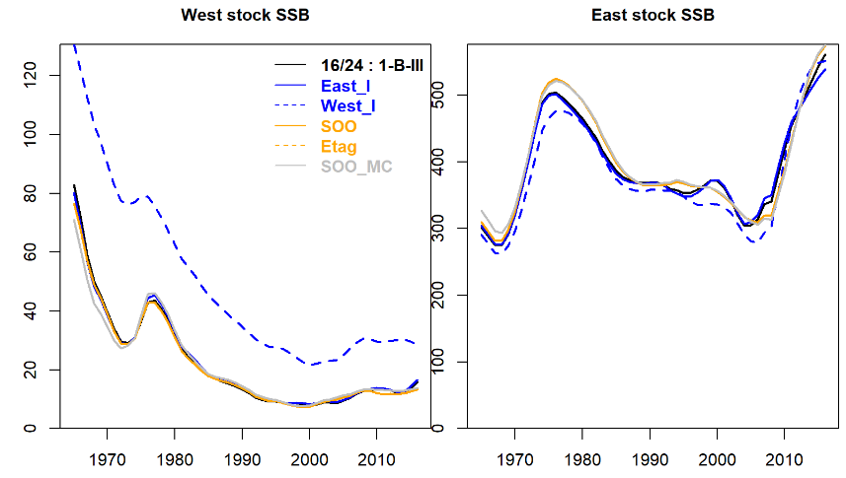

Figure 5b. As Figure 1b but for OM #16 (1BIII)

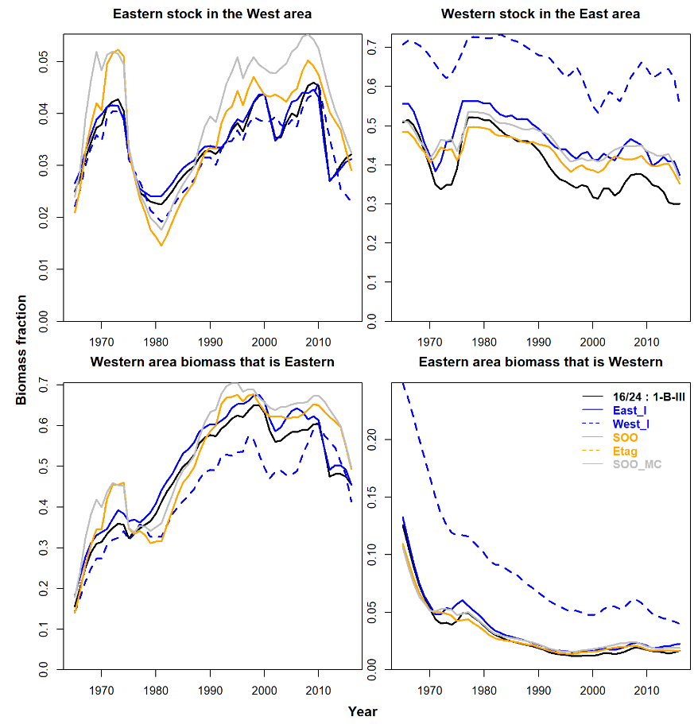

Figure 5c. As Figure 1c but for OM #16 (1BIII)

## Stock of origin composition over time

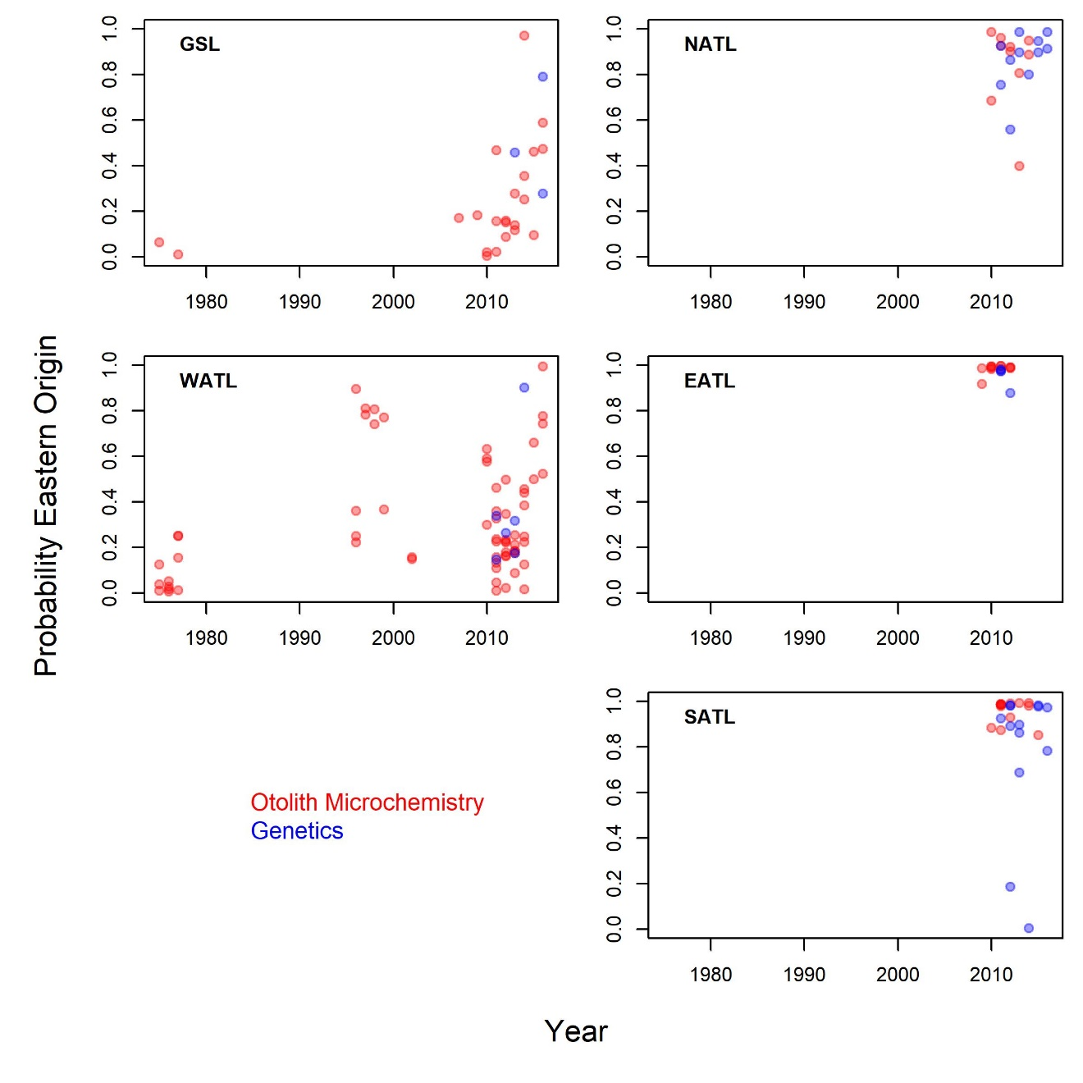

Figure 6. Probability fish are of Eastern stock of origin (derived by mixture model) for the various areas over time. Points represent the mean value.

## OM estimates

Table 6. Summary table (provided by Nakatsuka-san) comparing the various biologial values of OMs

|  |  |  |  |  |  |  |
| --- | --- | --- | --- | --- | --- | --- |
| OM | Current Biomass | | | B0 as BMSY/BMSY_B0 | | |
| B-east | B-west | E/W | B0-east | B0-west | E/W |
| 1 | 741,046 | 64,050 | 12 | 1,633,691 | 137,000 | 12 |
| 2 | 414,706 | 24,112 | 17 | 1,350,928 | 234,782 | 6 |
| 4 | 496,795 | 31,525 | 16 | 1,499,552 | 107,544 | 14 |
| 5 | 488,381 | 17,652 | 28 | 1,387,769 | 224,287 | 6 |
| 7 | 978,703 | 33,384 | 29 | 2,436,986 | 126,763 | 19 |
| 8 | 660,573 | 20,103 | 33 | 2,061,662 | 314,067 | 7 |
| 10 | 495,921 | 28,107 | 18 | 1,914,472 | 138,759 | 14 |
| 11 | 500,089 | 15,130 | 33 | 1,828,906 | 228,029 | 8 |
| 13 | 762,746 | 84,311 | 9 | 1,577,226 | 147,127 | 11 |
| 14 | 440,978 | 12,264 | 36 | 1,315,036 | 202,540 | 6 |
| 16 | 523,785 | 13,634 | 38 | 1,398,116 | 92,842 | 15 |
| 17 | 486,260 | 13,100 | 37 | 1,380,008 | 212,063 | 7 |
| 19 | 978,730 | 28,635 | 34 | 2,704,541 | 157,656 | 17 |
| 20 | 658,937 | 10,462 | 63 | 2,002,411 | 210,582 | 10 |
| 22 | 522,054 | 21,999 | 24 | 2,224,204 | 176,330 | 13 |
| 23 | 529,834 | 9,920 | 53 | 1,806,765 | 224,652 | 8 |
|  |  |  |  |  |  |  |
| R1_1 | 645,695 | 38,020 | 17 | 1,867,573 | 132,483 | 14 |
| R1_2 | 486,294 | 19,290 | 25 | 1,286,992 | 261,899 | 5 |
| R2_2 | 449,439 | 12,294 | 37 | 1,325,555 | 202,109 | 7 |
| R3_1 | 821,808 | 116,247 | 7 | 1,986,617 | 207,599 | 10 |
| R3_2 | 488,012 | 17,768 | 27 | 1,299,920 | 254,737 | 5 |
| R5_1 | 803,687 | 180,359 | 4 | 1,999,968 | 282,560 | 7 |
| R5_2 | 475,996 | 27,094 | 18 | 1,307,881 | 264,489 | 5 |
| R6_1 | 803,687 | 180,359 | 4 | 1,999,968 | 282,560 | 7 |
| R6_2 | 475,996 | 27,094 | 18 | 1,307,881 | 264,489 | 5 |

## Variability in results among East-West areas

In general, the variance in Western area biomass was considerably higher among sensitivity analyses than that of the Eastern Area. While there was similar uncertainty over spatial distribution of each stock, fluctuations in the much larger East stock mixing led to substantially higher variability in estimates of western area biomass.

## Eastern mixing into the West

Fishery independent indices favour smaller stocks (getting closer to the area-specific assessments, Figure 3a) and much lower mixing into the West area of Eastern fish, putting as low as 3% of the Eastern stock in the West area when upweighted (12% when downweighed) (Figure 3b). This pattern was contradicted by the electronic tagging data – when upweighted, 12% of Eastern fish were found in the west, 4% when down weighted. The stock of origin data favoured a similar pattern albeit weaker (10% Eastern fish in West when upweighted and 5 % when down weighted).

## Western mixing into the East

Interestingly, although both Electronic tagging data and Stock of Origin data infer higher rates of Eastern mixing into the Western area, they provide contradictory information about the fraction of western fish in the East. When upweighted, the Stock of origin data favour, as for the East stock, higher mixing and place as many as 40% of West fish in the Eastern area (Figure 1b). In contrast, the upweighted Electronic tagging data provide evidence of reduced mixing and put as few as 20% of fish in the East area.

## Principal conflicts

Table 7. The qualitative impact on biomass and mixing estimates of the various types of data.

|  |  |  |
| --- | --- | --- |
| **Type** | **More** | **Less** |
| East stock mixing in west |  |  |
| West stock mixing in east |  |  |
| East area spawning biomass |  |  |
| West area spawning biomass |  |  |
| Eastern stock spawning biomass |  |  |
| Western stock spawning biomass |  |  |
|  |  |  |
|  |  |  |

# Discussion

.

# Acknowledgements

We thank the ICCAT bluefin technical team for their continued feedback on operating model inputs, assumptions and estimates. This work was carried out under the provision of the ICCAT Atlantic Wide Research Programme for Bluefin Tuna (GBYP), funded by the European Union, several ICCAT CPCs, the ICCAT Secretariat and by other entities (see: http://www.iccat.int/GBYP/en/Budget.htm). The contents of this paper do not necessarily reflect the viewpoints of ICCAT or other funders and in no ways anticipate ICCAT future policy in this area.

# References

Anon. 2017. Report of the 2017 ICCAT bluefin stock assessment meeting. International Commission for the Conservation of Atlantic Tunas. Available online at: <https://www.iccat.int/Documents/SCRS/DetRep/> BFT_ASS_ENG.pdf [accessed October 2018]

1. IOF, 2202 Main Mall, University of British Columbia, Vancouver, B.C., Canada, V6T 1Z4. [t.carruthers@oceans.ubc.ca](mailto:t.carruthers@oceans.ubc.ca)
2. Dept Maths and Applied Maths, University of Cape Town, Rondebosch 7701, South Africa. [doug.butterworth@uct.ac.za](mailto:doug.butterworth@uct.ac.za)